# IoT Enabled Prediction of Diabetic-Cardio Disease through Fog Computing using Supervised and Unsupervised Algorithms

A Project Report Submitted to

**Jawaharlal Nehru Technological University Anantapur, Ananthapuramu**

in partial fulfillment of the requirements for

the award of the degree of

**BACHELOR OF TECHNOLOGY**

**IN**

**INFORMATION TECHNOLOGY**

*Submitted by*

**Batch No: A13**

|  |  |
| --- | --- |
| **Adoni Sai Pavithra** | **18121A1203** |
| **C.Samanvitha** | **18121A1213** |
| **G. V. Sai Tharun** | **18121A1226** |
| **C H. Nikhitha** | **18121A1211** |

Under the Supervision of

**Dr. K. K. Baseer,** *M.Tech., Ph.D.*

Associate Professor

Department of Information Technology



Department of Information Technology

**SREE VIDYANIKETHAN ENGINEERING COLLEGE**

(AUTONOMOUS)

(Affiliated to JNTUA, Ananthapuramu, Approved by AICTE, Accredited by NBA & NAAC)

Sree Sainath Nagar, Tirupati – 517 102, A.P., INDIA

2021-2022

Department of Information Technology

**SREE VIDYANIKETHAN ENGINEERING COLLEGE**

**(AUTONOMOUS)**

(Affiliated to JNTUA, Ananthapuramu, Approved by AICTE, Accredited by NBA & NAAC)

Sree Sainath Nagar, Tirupati – 517 102, A.P., INDIA



**Certificate**

This is to certify that, the project work entitled

**“IoT Enabled Prediction of Diabetic-Cardio Disease through Fog Computing using Supervised and Unsupervised Algorithms”**

is the bonafide work done by

|  |  |
| --- | --- |
| Adoni Sai Pavithra | 18121A1203 |
| C.Samanvitha | 18121A1213 |
| G. V. Sai Tharun | 18121A1226 |
| C H. Nikhitha | 18121A1211 |

in the Department of **Information Technology**, **Sree Vidyanikethan Engineering College (Autonomous), Sree Sainath Nagar, Tirupati** and is submitted to **Jawaharlal Nehru Technological University Anantapur, Ananthapuramu** for partial fulfillment of the requirements of the award of B.Tech degree in Information Technology during the academicyear 2021-2022.

|  |  |
| --- | --- |
| Supervisor:  **Dr. K. K. Baseer,** *M.Tech., Ph.D.*  Associate Professor  Dept. of Information Technology  Sree Vidyanikethan Engineering College  Sree Sainath Nagar, Tirupati – 517 102 | Head of the Dept.:  **Dr. K. Ramani,** *M.Tech., Ph.D.*  Professor  Dept. of Information Technology  Sree Vidyanikethan Engineering College  Sree Sainath Nagar, Tirupati – 517 102 |

**INTERNAL EXAMINER EXTERNAL EXAMINER**

ACKNOWLEDGEMENTS

We are extremely thankful to our beloved Chairman and Founder **Dr. M. Mohan Babu,** Padma Shri awardee who took keen interest and encouraged us in every effort throughout this course.

We owe our gratitude to **Dr. B. M. Satish**, Principal, Sree Vidyanikethan Engineering College (Autonomous) for permitting us to use the facilities available to accomplish the project successfully.

We express our heartfelt thanks to **Dr. K. Ramani**, Professor and Head, Department of Information Technology, for her kind attention and valuable guidance to us throughout this course.

We are thankfull to our Project Coordinator **Dr. V. Lokanadham Naidu,**

Associate Professor of IT for his valuable support and guidance throughout the project work.

We are extremely thankful to our Project Supervisor **Dr. K. K. Baseer,**

Associate Professor of IT who took keen interest and encouraged us in every effort throughout this project.

We also thank all the teaching and non-teaching staff of Information Technology Department for their cooperation.

**Project Associates**

|  |
| --- |
| Adoni Sai Pavithra |
| C. Samanvitha |
| G. V. Sai Tharun |
| C H. Nikhitha |

# ABSTRACT

The Internet is extremely important in today's modern environment. The Internet of Things (IoT) is characterized by a greater number of wired and wireless sensors. These sensors are networked devices that create massive amounts of data, reaction time, latency, and security vulnerabilities. Therefore, in order deal with such huge data we use fog computing, a well-known distributed architecture. Fog computing works with the aim to enhance the processing, intelligence, and accumulation of data closer to the Edge devices. In this project, diabetes and cardiovascular illnesses are considered in this study for prediction based on patient health records. Initially, patient health data is acquired and stored using Sensor devices. A group of patient health records is first subjected to the unique rule-based clustering technique. Finally, we consider diabetes and cardiovascular diseases in our study. To test the performance of the suggested task, a rigorous experiment and study using healthcare data were conducted. Various Machine Learning (ML) algorithms are applied to patient health information, and the prediction result, as well as the accuracy of each algorithm, is generated. The findings show that the proposed work accurately predicts cardiac and diabetes problems, identifies which algorithm has the highest accuracy among them, and reduces cloud burden. Devices having inbuilt sensors used in this work are pulse oximeter, smart watch, glucometer and thermometer. Machine Learning Algorithms considered here are KNN, Naïve Bayes (Gaussian), Logistic Regression.

**Keywords**: Fog Computing, Machine Learning, Internet of Things (IoT).

# TABLE OF CONTENTS

**TITLE PAGE NO.**

**ABSTRACT** i

**TABLE OF CONTENTS** ii

**LIST OF FIGURES** iii-iv

**LIST OF TABLES** v

**CHAPTER 1: INTRODUCTION 1-3**

**CHAPTER 2: LITERATURE REVIEW 4-13**

**CHAPTER 3: SYSTEM ANALYSIS 14-21**

3.1. Proposed System

3.1.1. Workflow

3.2. Algorithms

3.2.1. Algorithm 1:K-Nearest Neighbor (KNN)

3.2.2. Algorithm2: Logistic Regression

3.2.3. Algorithm3: Gaussian NB

**CHAPTER 4: SYSTEM DESIGN AND IMPLEMENTATION 22-32**

4.1. Requirements

4.2. Devices

4.3. Design Using UML Diagrams

4.4. Project Implementation Details

**CHAPTER 5: TESTING 33-34**

**CHAPTER 6: RESULTS 35-37**

**CHAPTER 7: CONCLUSIONS 38**

**REFERENCES 39-40**

# LIST OF FIGURES

**FIGURE NO.** **TITLE PAGE NO.**

**Figure 1.1** Gartner’s hype cycle for healthcare 3

**Figure 2.1** Flowchart heart and diabetic System. 13

**Figure 3.1** Architecture of proposed system. 14

**Figure 3.2** Work Flow of proposed system. 16

**Figure 3.3** Modelling of ML 17

**Figure 4.1** Pulse Oximeter for collecting heart rate 23

**Figure 4.2** Use case diagram for disease prediction 24

**Figure 4.3** Activity diagram for disease prediction 25

**Figure 4.4** Sequence diagram for disease prediction 26

**Figure 4.5** Class diagram for disease prediction 27

**Figure 4.6** Implementation of IoT Enabled Prediction of

Diabetic-Cardio Disease through Fog Computing 28

**Figure 4.7** Showing Fog Environment 29

**Figure 4.8** Showing PhpMyAdmin 30

**Figure 4.9** Home.html 31

**Figure 4.10** Patient details. 31

**Figure 4.11** Login Process 31

**Figure 4.12** Showing file upload in S3 bucket 32

**Figure 4.13** Showing Upload button to upload results 32

**Figure 6.1** KNN Accuracy Graph 35

**Figure 6.2** LR Accuracy Graph 35

**Figure 6.3** Naïve Bayes Accuracy Graph 36

**Figure 6.4** Graph representing number of patients 36

visited each doctor

**Figure 6.5** Graph Showing Real Time Values of 37

Male Patients

**Figure 6.6** Graph Showing Real Time Values of 37

Female Patients

# LIST OF TABLES

**TABLE NO.** **TITLE PAGE NO.**

**Table. 5.1** Table showing the Testcases, Expected and 33-34

Actual Outputs

# INTRODUCTION

The main research area of the project is IOT and Fog Computing. Fog computing refers to a decentralized computing structure. The resources, including the data and applications, get placed in logical locations between the data source and the cloud. One of the advantages of fog computing is to keep many users connected to the internet at the same time. In essence, it offers the same network and services that cloud-based solutions provide, but with the added security of a decentralized network.

The topics related to this area are Workload balancing and scheduling in Fog/Edge computing for IoT, Green Fog/Edge computing, Fog/Edge computing applications in connected autonomous vehicles, Industry 4.0, smart homes, and smart cities, Modelling and performance analysis of Fog/Edge computing for IoT. Our current research topic is IoT Enabled Prediction of Diabetic-Cardio Disease through Fog Computing using Supervised and Unsupervised Machine Learning Algorithms.

The main advantages of the topic are User can search for doctor’s help at any time, User can talk about their Heart disease and get instant diagnosis, Doctors get more clients online and it is very useful in case of emergency. The disadvantages of the topic are Accuracy issues: A computerized system alone does not ensure accuracy, and the warehouse data is only as good as the data entry that created it. The system is not fully automated, it needs data from user for full diagnosis.

The applications on which the topic can be used are Connected cars, Smart grids and smart cities and real time analytics. The topic is all about prediction of cardio and diabetes disease by taking some parameters (health data) from the patient using fog computing. The topic is adapted to hospital management system. Any user can give the health data about him/her and can get the results about cardiac and diabetes occurrence.

The continuous increase in chronic diseases, population and cost of healthcare have led to the revolution of remote health monitoring. This results in increasing usage of number of sensors or IoT devices. These devices produce a large amount of data, which must be properly collected and saved in the limited storage capacity available. Cloud computing technology offers limitless resources that can be paid for as needed.

The Fog Computing concept is developed to solve the above problem Fog Processing is a processing, storage, and communication architecture that connects a cloud to a number of "peripheral" devices in close proximity to EDGE devices. Fog computing's major goal is to do as much processing as feasible near EDGE devices so that processed data may be transferred and bandwidth requirements can be reduced.

A Fog Computing architecture has three layers.

* Sensor layer
* Fog Layer
* Cloud Layer

All the devices in the sensor layer are interconnected using a Fog Node. A Fog Node is a **physical device that provides an aid in deployment of fog computing**.It acts as a mini cloud. Instead of using a Physical device, Fog Nodes can be created virtually using simulators.

In our implementation, Cardio and Diabetics related data is read from Sensor devices and sent to a Fog Node where computation is done and results are predicted. All of these characteristics are collected and fed into the diagnostic system. Once the prediction result is obtained, the result is stored in an excel sheet. This is uploaded into AWS S3 bucket in the cloud. This way the amount of raw data and unwanted data can be reduced before sending to the cloud. This results in reducing the latency, load on data centres and also reduces the cost.

Using fog computing to assist in the verification of patients with ongoing illnesses to the point where information is captured and processed efficiently. The most difficult part would be isolating the context-sensitive data that is pertinent to the patient's health. Simply having a sensor-cloud architecture isn't enough, which is where a fog computation layer comes in handy. This increases the system's feasibility by lowering the amount of data sent back and forth between the cloud and the sensors, as well as alleviating server ranch dissatisfaction.

We collected heart rate, oxygen level, glucose level, temperature, and blood pressure using devices such as a Smart Watch, Pulse Oximeter, Glucometer, Thermometer, and Blood Pressure Monitor. These devices are placed near the user so that they can utilise them to acquire predictions and schedule appointments.

Following the acquisition of patient facts, an algorithm is constructed to make a dynamic choice on health care data and decision making in the fog and cloud. For delay-sensitive real-time applications, a low latency health care application is available.

Fog computing works closer to the user, on the network edge, allowing for accurate service delivery with a fast response time, eliminating delays and network faults that could disrupt or delay the decision-making process and healthcare service delivery. In the next Section II Literature survey it explains about the works related to fog computing and IoT. In Section III System Analysis describes about proposed methodology and workflow. In Section IV System design and implementation describes about software and hardware requirements, UML diagrams and details about implementation. In Section V Testing describes about complete implementation details. In Section VI Results describes about final results. Finally, Section VI conclusion concludes the topic.

**courtesy:**https://info.thoughtwire.com

**Fig. 1.1. Gartner’s hype cycle for healthcare**

# 2. LITERATURE SURVEY

In **[1],** This study presents fog computing-based efficient Blockchain-based safe healthcare services for disease prediction. For safety and security, patient health data is collected from Fog Nodes and stored on a Blockchain.The obtained patient data is now fed into a classification and clustering algorithm, which categorises and organises patient health data based on specific criteria. Finally, a feature selection-based adaptive neuro-fuzzy inference method is used to predict diabetes and cardiovascular problems.

* To ensure safe and effective data storage and sharing, a semi-centralized Blockchain-based digital healthcare network for the protection and sharing of patient data has been built.
* The diabetes and heart disease patient records are grouped using a rule-based clustering approach.
* ANFIS is utilized to forecast diabetes and cardiovascular sickness based on feature selection after this clustering. To ensure safe and effective data storage and sharing, a Blockchain-based digital healthcare network for the protection and sharing of patient data is introduced.

There are five entities in the proposed system's model.

1. MEDICAL SENSOR DEVICES
2. FOG NODE
3. BLOCKCHAIN
4. CLOUD
5. MEDICAL ANALYZER

Wearable systems and embedded technologies both use sensors to monitor human health. Sensor data is collected and stored by Fog Nodes. The encrypted patient health information is stored in the Cloud, and the authenticated medical analyst can access it for further processing. The analyzer may divide the data into two categories: normal and impacted patients.

**Limitations:**

* Doesn’t provide any graphical User Interface to the user.
* This paper uses SHA256 which again has some other disadvantages like **ASIC Dominance, Current Mining Profitability**

In **[2],** By adding a layer of mid-fog at the edge to raise their abilities and resources, this article presents the Fog Chain architectural paradigm, which blends Blockchain, fog computing, and IoT for improved health outcomes.

This study describes an artificial intelligence system that collects EHR data from handheld IoT devices using a wireless sensor network (WSN) architecture at the network's perimeter. Before transactions are saved in the cloud, the blockchain security layer validates, encrypts, and standardises them. A fundamental component of this system is a decentralised cloud platform for IoT data storage. A decentralised cloud platform for IoT data storage is a key component of this system. The architecture of the Fog Chain is built on **JavaScript and Node.js.**

Fog Chain’s architecture consists of four main components:

1. IoHT Layer
2. Fog Layer
3. Blockchain Peers
4. Smart Contracts.

**Limitations**:

* Our Fog architecture is built around a single server that runs containers on virtualized nodes.
* The assessment does not include scenarios where different nodes are available.
* We created a one-of-a-kind application to extract data from a dataset and input it into the system.

In **[3],** In this study, Cloud and Fog Computing are used to construct a real-time Electro Cardio Gram (ECG) based healthcare system. For measuring system performance improvement, As Quality of Service (QoS) indicators, we assessed memory usage, transmission delays, computation delays, network delays, carbon dioxide emissions, data delivered, and response time.

**Aim and objectives**

* To support latently sensitive health care IoT applications, expand cloud to cloud.
* To meet Service Level Agreements (SLAs) in terms of reaction time and resource utilisation, the Smart Fog Gateway should be designed with intelligent resource allocation in mind.
* Develop a fog and cloud-based dynamic decision-making algorithm for health-care data and decision-making.
* Develop a robust, cost-effective, and energy-efficient community-based health-care approach.

**Scope of the paper**

* Even when not connected to the cloud layer, interactive fog layer communication is possible.
* Low-latency health-care application for delay-sensitive real-time applications.
* Compare the performance of fog vs cloud computing.
* Discuss the Fog Computing implementation and deployment.
* Determine the Fog computer system's health-care limitations.

Three AD8232 electrode-based sensors capture the real-time ECG signal in this system, and Arduino Nano performs the analog-to-digital converter (ADC). When these measurements are drawn, they reveal the true ECG waveform.

To create a Fog Computing node, a Raspberry Pi Model 3 B+ is utilised, and many environmental installation and configuration tasks are completed.

**Limitations**:

* The Raspberry Pi's hardware and primary memory capacity is limited by the amount of electricity available. As a result, machine learning-based apps are not compatible with the Raspberry Pi.
* Deployments will slow down procedures, which in healthcare applications is undesirable.

In **[4],** Use fog computing to help verify individuals with continuing illnesses to the point where information can be captured and processed efficiently in this document. The most difficult part would be isolating the context-sensitive data that is pertinent to the patient's health. Because a sensor-cloud architecture is insufficient, a fog computation layer is required. This increases the system's feasibility by lowering the amount of data sent back and forth between the cloud and the sensors, as well as alleviating server ranch dissatisfaction.

We intend to improve existing health systems by introducing a context-sensitive fog computing environment into this study.

By incorporating a context-sensitive fog computing environment into this study, we hope to improve existing health systems.

**Sensors Tier**

* The sensors' job is to collect all of this information and provide it to the fog processing layer.
* The patient's portable sensors capture both extrinsic (temperature, location) and intrinsic (blood pressure, blood glucose, heart rate) parameters.
* Patients can also enter information into their smartphones, which will be used to treat them.

**Fog Computing Tier**

* **Work distribution:**

For cloud and fog computing systems, we use Task Planning Mechanism to distribute work.

* **Data aggregation:**

The three basic components of data aggregation are mapping, duplicate identification, and data fusion.

**Cloud Computing Tier**

* Cloud computing allows for continuous monitoring of the health monitoring system.
* It is the layer that coordinates the many operations that the health surveillance system must perform.
* The monitoring programme includes a component that monitors the sensors, collects data, and sends it to the fog layer.

**Health Monitoring System**

The information flow between these four levels must be effectively managed.

**Simulation of the Fog Environment**

As a result, several significant privacy and security issues must be addressed.

We used the IFogSim tool module to simulate the mist organisation in order to think about the utilisation of mist processing versus traditional distributed computing in medical services.

**Limitations:**

* Our implementation has been slowed by a lack of widely available software.

In **[5],** A fog infrastructure is a collection of Fog gateways that are directly connected to mobile devices to provide low latency and high-quality services. To address these difficulties, a distributed deep learning model (1D-CNN) was developed that uses the Fog and Cloud infrastructures to perform inference and training operations.

A well-established remote monitoring system for cardiac patients is being deployed in addition to the proposed DL model. Experiments have shown that by analysing IoT device-generated ECG readings with more precision, the recommended approach can give low latency responses in diagnosing emergency situations for cardiac patients.

Fog gateways receive data directly from mobile devices using a wireless communication protocol like Bluetooth Low Energy (BLE) or Wi-Fi. The proposed method then uses a machine learning model to predict cardiovascular disease based on ECG data gathered.

**Limitations**:

* The use of ECG analysis in wearable devices reduces the battery life.

In **[6],** HealthFog is a recommended framework for incorporating deep learning into Edge computing devices and sending it for usage in real-world heart disease assessments.

The following are the document's main contributions:

* A recommendation for employing a standard framework engineering methodology to improve deep learning on fog computing.
* Developed HealthFog, a lightweight automatic cardiac patient data diagnostic solution based on ensemble deep learning.
* Implementation of HealthFog for real-time IoT-Edge-Cloud data processing utilising the FogBus framework.
* Demonstration and analysis of the HealthFog deployment in terms of precision, reaction time, network data transmission capacity, and energy consumption.

**Health Fog Design**

The data from the cardiac patient is sent into the fog computation model, which determines whether or not the patient has heart disease.

* Information on cardiac patients is preprocessed.
* Install the Deep Learning app.
* Communication and Android interface.

**Experimental Setup in this paper:**

**Gateway Device**: Android 9 on the Samsung Galaxy S7

**Broker/Master Node**: The Dell XPS 13 has a 2.50GHz Intel(R) Core(TM) i5-7200 processor, 8GB DDR4 RAM, and 64-bit Windows 10. Apache HTTP Server 2.4.34 was used for the deployment.

**Worker Node**: Raspberry Pi 3B+ Worker Node includes a quad-core ARM Cortex-A53 SoC, 1GB LPDDR2 SDRAM, and IEEE 802.11 Wifi. The Raspbian Stretch operating system uses the Apache HTTP server version 2.4.34.

**Public Cloud:** Microsoft Azure B1s Machine, 1vCPU, 1GB RAM, 2GB SSD, Windows Server 2016

**Limitations:**

* File based input data.
* Only for Cardio Disease.

In **[7],** Because edge devices or fog nodes with greater processing capabilities may handle heart patient data, this article employs fog computing to reduce the delay, reaction time, and latency that arise due to IoT devices' closeness to edge devices when compared to cloud data centres. Despite the fact that a large number of cardiac patients must be cared for, current systems have sluggish response times, heavy workloads, high resource utilisation, and high energy consumption.

The "smart heart disease prediction system" collects data from heart patients using smart gadgets or Internet of Things devices. Environmental sensors, medical sensors, and activity sensors are examples of hardware components that are placed on a patient's body. The data or information collected from the body includes activity level, blood pressure, EEG, blood oxygen, EMG, respiration rate, and ECG. Gateway devices process data before sending it to worker or broker nodes for heart disease prediction.

The lowest and largest mean, standard deviation, kurtosis, and skewness are utilised to derive features from other attributes. A smart heart disease prediction system with a broker node, a worker node, and a cloud data centre using the FogBus. Finally, the data is fed into the diagnosis system, which employs an upgraded CCNN to determine whether the patient has cardiac disease.

FogBus is used in this suggested concept to deliver services for forecasting patients' heart problems.

In **[8],** This study creates a stroke detection and prediction system based on IoT and fog computing.

Three layers make up the suggested monitoring system's architecture. These are the layers

* Cloud Layer
* Patient Information Layer
* Fog Computing Gateway Layer.

The Patient Information Layer gathers information about health, location, activity, personal, behavioural, and environmental factors, among other things. The fog computing gateway layer sends the data to be processed and diagnosed. An ensemble classifier is employed to predict the stroke in this layer. When a stroke is predicted, patients receive an alarm message and can take preventative measures. The cloud layer is responsible for storing and distributing processed data to doctors, hospitals, and patients' relatives. The stroke's impact is also calculated using the recorded information. Some users may see warning messages.

Patients who have had a stroke are examined for improvement and a history report on a regular basis. Stroke victims are tracked using regular time intervals. Patients suffering a stroke are typically evaluated every three hours, with a favourable outcome after ten hours. The recovery period for stroke victims is not fixed in stone, and it varies depending on the doctor.

To lessen the overburden on the cloud layer, the suggested RFB classifier is coupled to the fog computing gateway layer. The proposed monitoring method is more accurate than another algorithm under consideration.

In **[9],** We presented a thorough literature review in this paper to provide an overview of fog computing research in health care. By assisting elderly in their homes, fog computing makes a significant contribution to health care applications.

Kitchenham's original work defined the following activities, which we employed to conduct a systematic literature review:

questions for investigation

Search method

Selection of articles

The study distribution

Evaluation of quality

We have also offered a new scientific categorization and an updated review of the major barriers and concerns in the Fog Computing and healthcare field of study, as well as a refreshed study on information types, designs, client types, profiles, and section tactics.

In **[10],** FogMed is a fog-based technology that uses medical sensor data streams to forecast disease. By addressing two goals: fog service QoS guarantee and medical data stream anomaly prediction, this system intends to improve disease prediction accuracy**.**

To validate FogMed's performance, we create a virtual FogMed environment and conduct thorough research on the public ECG dataset.

It can gather and store physical data about patients, analyse and predict abnormalities using such data, and improve fog service QoSs. The purpose of screening patients is to notice or anticipate their peculiarities as soon as possible, so that the appropriate medicines may be administered ahead of time to maintain patient health.

FogMed operates in a limited geographic area. FogMed makes use of both fog and cloud resources, addressing the fog layer's lack of processing and storage resources as well as the cloud layer's network congestion and task overload. Furthermore, building or using small fog devices near small emergency clinics or people is easier and more feasible.



**Fig. 2.1. Flowchart representation of prediction System**

# SYSTEM ANALYSIS

This project proposes a prediction methodology using machine learnings. Here, we have taken 2 datasets (Heart and diabetes) from kaggle with 14 and 9 attributes respectively. Age, sex, type of chest pain, resting blood pressure, serum cholestoral in mg/dl, fasting blood sugar > 120 mg/dl, resting electrocardiographic results, maximum heart rate achieved, exercise induced angina, oldpeak, slope of the peak exercise ST segment, number of major vessels, thal and Pregnancies are just a few.

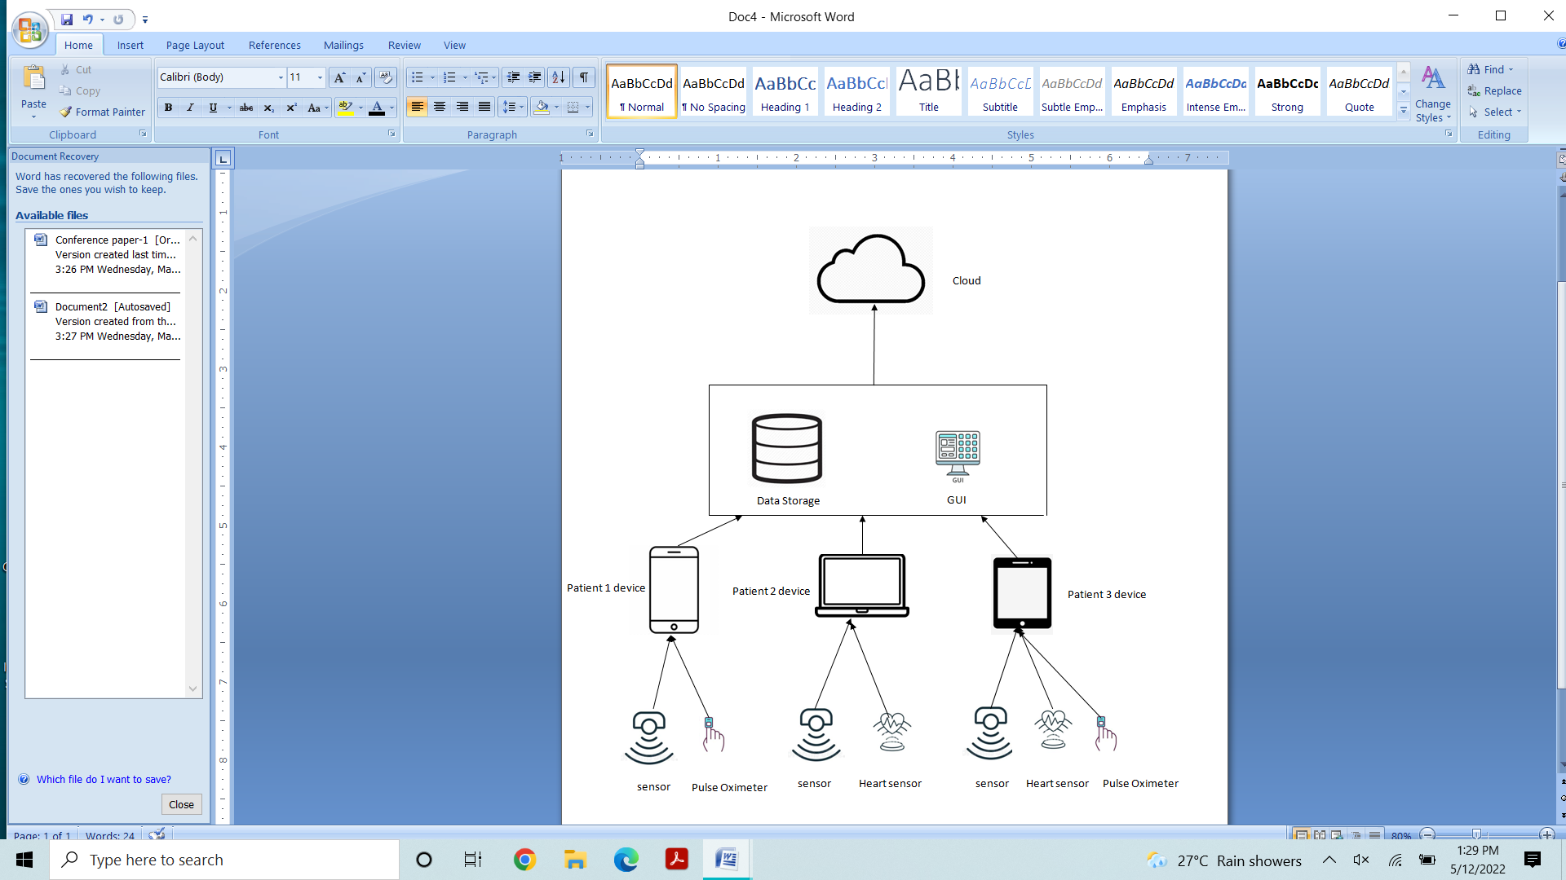

**Fig. 3.1. Architecture of IoT Enabled Prediction of Diabetic-Cardio Disease through Fog Computing using Supervised and Unsupervised Machine Learning Algorithms.**

# 3.1. PROPOSED SYSTEM

In our experiment, we created a fog environment by connecting different devices into a same network. Here a computer that is storing and processing the information is considered as a Fog Node. We built a web page for taking the input from the user and undergoes machine learning concepts for giving the results.

We proposed a three-layered architecture.

1.Terminal Layer

2.Fog Layer

3.Cloud

One or more devices linked inside the same network are examined for providing input to the Fog Node at the terminal layer. These devices can be a mobile, computer or a laptop, tablet etc.

In Fog Layer, the inputted information is pre-processed and result is obtained.

In Cloud Layer, the obtained results are stored.

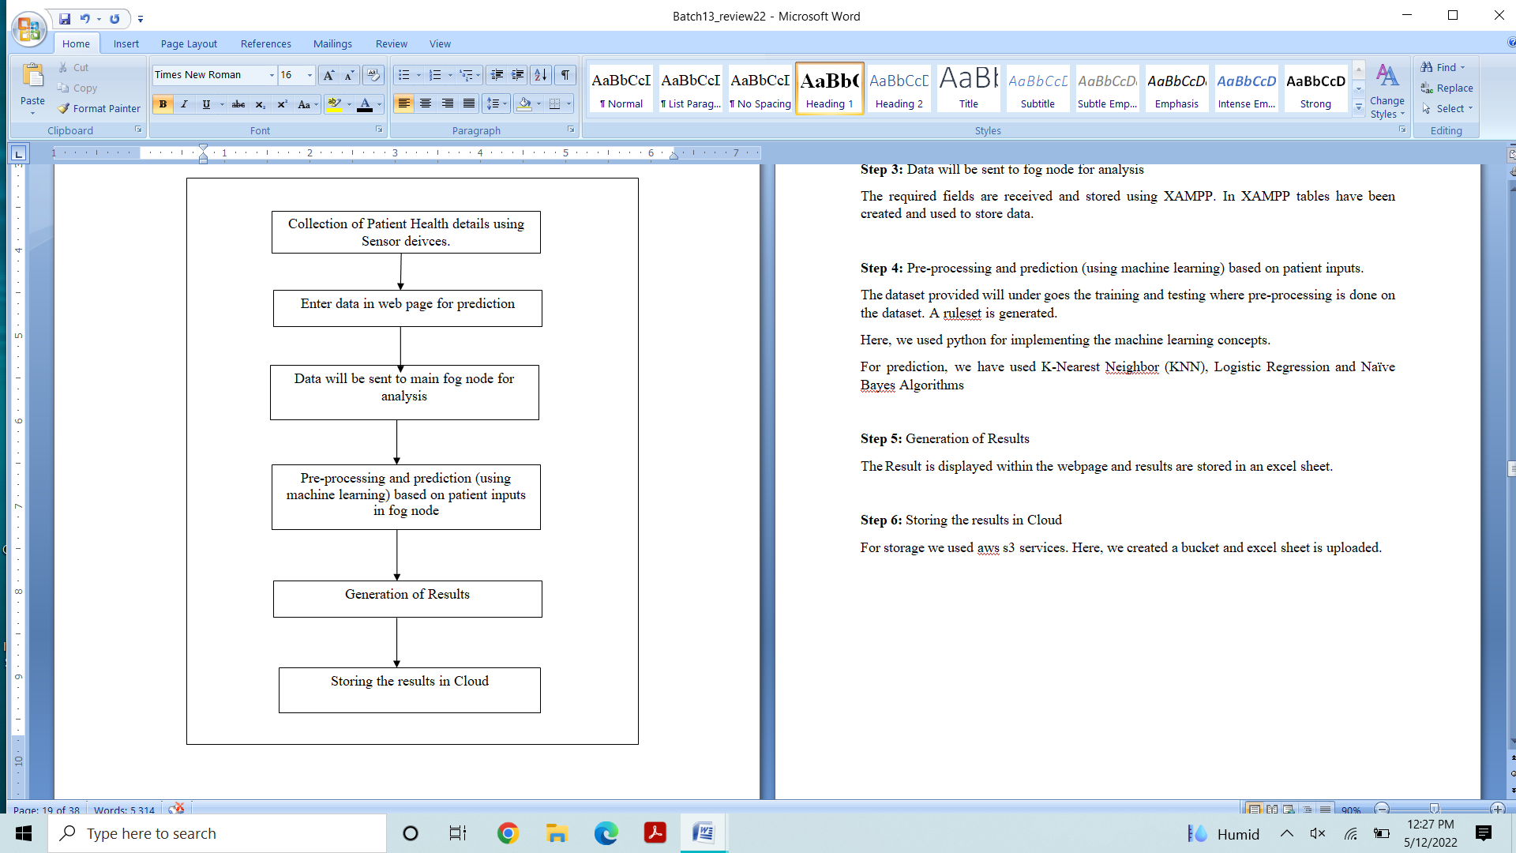3.1.1. **WORKFLOW  
 Fig. 3.2. Workflow of proposed system**

**Step 1:** Collection of Patient Health details using Sensors

In this step, We used sensors to collect health Data of a patient. Sensors may be pulse oximeter, smart watch, glucometer and thermometer.

**Step 2:** Enter the data in web page

In this step, we created a webpage having the fields required for prediction of heart and diabetic disease. We enter the collected data from sensors to web page.

For creating the webpage, we used HTML, PHP, JAVA SCRIPT

**Step 3:** Data will be sent to fog node for analysis

The required fields are received and stored using XAMPP. In XAMPP tables have been created and used to store data.

**Step 4:** Pre-processing and prediction (using machine learning) based on patient inputs.

The dataset provided will under goes the training and testing where pre-processing is done on the dataset. A ruleset is generated.

Here, we used python for implementing the machine learning concepts.

We employed K-Nearest Neighbor (KNN), Logistic Regression, and Nave Bayes Algorithms for prediction.

**Step 5:** Generation of Results

The Result is displayed within the webpage and results are stored in an excel sheet.

**Step 6:** Storing the results in Cloud

For storage we used AWS S3 services. Here, we created a bucket and excel sheet is uploaded.

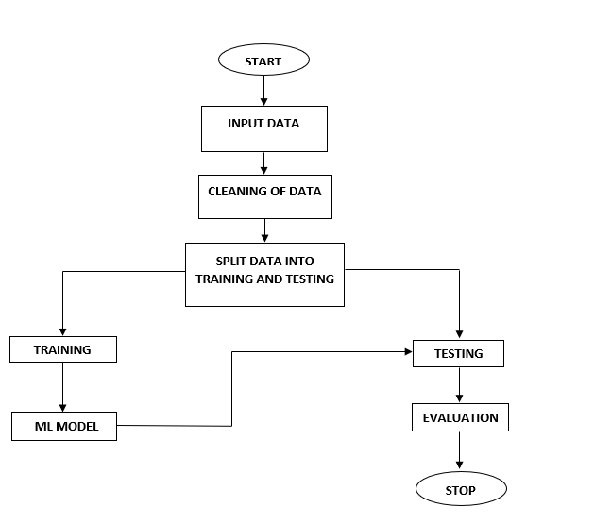

**Fig. 3.3. Modelling of ML**

The modelling process of machine learning algorithms is depicted in this block diagram. Training and testing sets are created from pre-processed data.The ML models can be fitted using training data. The model is then tested using testing set and derived accuracies were recorded.

**Advantages of proposed system:**

* Reduces load on cloud.
* Any moment, the user can seek medical help.
* Users can talk about their heart problems or diabetes and get a quick diagnosis.
* Doctors get more patients by advertising online.
* Extremely useful in an emergency.

**Disadvantages of proposed system:**

* Correctness Issues: A computerised system by itself cannot guarantee accuracy, and warehouse data is only as good as the data entry that generated it.
* The system is not totally automated; for a complete diagnosis, it requires data from the user.

# ALGORITHMS

# Algorithm 1: K-Nearest Neighbor (KNN)

* **Step-1:** Choose the Kth neighbor's number (we have taken k as 5)
* **Step-2:** Calculate the distance between K neighbours in Euclidean space.
* **Step-3:** Choose the K nearest neighbours based on the Euclidean distance.
* **Step-4:** Count how many data points there are in each area of these k neighbours.

*Start*

*Declare model, X_train_prediction, lr_training_data_accuracy, X_test_prediction,*

*lr_test_data_accuracy*

*Call KNN() and store it in model*

*Call model.fit(X_train, Y_train)*

*Call model.predict(X_train) and store it in X_train_prediction*

*Call accuracy_score(X_train_prediction, Y_train) and store it in*

*lr_training_data_accuracy*

*lr_training_data_accuracy<-"{:.2f}".format(lr_training_data_accuracy*100)*

*Print Accuracy on Training data*

*Call model.predict(X_test) and store it in X_test_prediction*

*Call accuracy_score(X_test_prediction, Y_test) and store it in*

*lr_test_data_accuracy*

lr_test_data_accuracy<- "{:.2f}".format(lr_test_data_accuracy*100)

*Stop*

**Advantages of KNN Algorithm:**

* It is simple to put into practise.
* It can handle noisy training data.
* Accuracy increases higher with larger datasets.

**Disadvantages of KNN Algorithm:**

* Determining the k value always is a complex process some times.
* Because the distance between data points for every training samples must be determined, the computation cost is high.

# Algorithm 2: Logistic Regression

* **Step-1:** Pre-processing of data
* **Step-2:** The Training Set and Logistic Regression
* **Step-3:** Predicting the test result
* **Step-4:** Testing the accuracy of the outcome (Creation of Confusion matrix)
* **Step-5:** Visualizing the results of the test set

*Start*

*Declare model,X_train_prediction, lr_training_data_accuracy, X_test_prediction,*

*lr_test_data_accuracy*

*Call LogisticRegression() and store it in model*

*Call model.fit(X_train, Y_train)*

*Call model.predict(X_train) and store it in X_train_prediction*

*Call accuracy_score(X_train_prediction, Y_train) and store it in*

*lr_training_data_accuracy*

*lr_training_data_accuracy<-"{:.2f}".format(lr_training_data_accuracy*100)*

*Print Accuracy on Training data*

*Call model.predict(X_test) and store it in X_test_prediction*

*Call accuracy_score(X_test_prediction, Y_test) and store it in*

*lr_test_data_accuracy*

*lr_test_data_accuracy<- "{:.2f}".format(lr_test_data_accuracy*100)*

*Stop*

**Advantages of Logistic Regression:**

* Simplicity and transparency.
* Giving probabilistic output.
* Feature importance and direction.
* Able to do online-learning.

**Disadvantages of Logistic Regression:**

* The assumption of linearity in the logit can rarely hold
* Uncertainty in Feature importance.
* Not robust to big-influentials.
* Require more data.

# Algorithm 3: GaussianNB

* **Step-1:** Make frequency tables with the information provided.
* **Step-2:** Determine the likelihood of the supplied attributes to produce a Likelihood table.
* **Step-3:** Using Bayes theorem, determine the posterior probability.

*Start*

*Declare model, X_train_prediction, g_training_data_accuracy*

*X_test_prediction, g_test_data_accuracy*

*Call GaussianNB() and store it in model.*

*model.fit(X_train, Y_train)*

*Call model.predict(X_train) and store it in X_train_prediction*

*Call accuracy_score(X_train_prediction, Y_train) and store it in*

*g_training_data_accuracy*

*g_training_data_accuracy="{:.2f}".format(g_training_data_accuracy*100)*

*print Accuracy on Training data*

*call model.predict(X_test) and store it in X_test_prediction*

*Call accuracy_score(X_test_prediction, Y_test) and store it in g_test_data_accuracy*

*g_test_data_accuracy="{:.2f}".format(g_test_data_accuracy*100)*

*print Accuracy on Test data*

*Stop*

**Advantages of Naïve Bayes Classifier:**

* Naïve Bayes is a machine learning algorithm that predicts a class of datasets quickly and easily.
* It works for both binary and multi-class classifications.
* When compared to other Algorithms, it performs better in Multi-class predictions.
* It is the most commonly used method for text classification

**Naïve Bayes Classifier drawbacks:**

* Naive Bayes is unable to learn the link between features because it assumes all features are independent or unconnected.

# SYSTEM DESIGN AND IMPLEMENTATION

# REQUIREMENTS

**Hardware Requirements**

Basic hardware specifications needed for a system to this project are

* A Minimum I7 intel processor or any other equivalent processor is required
* Used a Standard keyboard
* Used Two or Three Button Mouse
* Used 256 GB of Hard Disk
* Used min of 8GB RAM
* 3g/4g mobile phone.
* Health devices:
* Pulse oximeter
* Glucometer
* **Sphygmomanometer**
* **Smart Watch**

**Software Requirements**

* The Windows Operating System is required.
* Xampp is for creating a server and Backend storage.
* Python IDLE
* Libraries used are
* Flask
* Pandas
* NumPy
* scikit-learn

# DEVICES

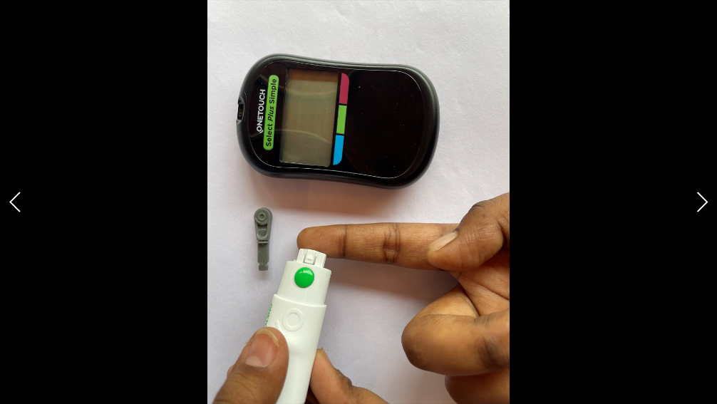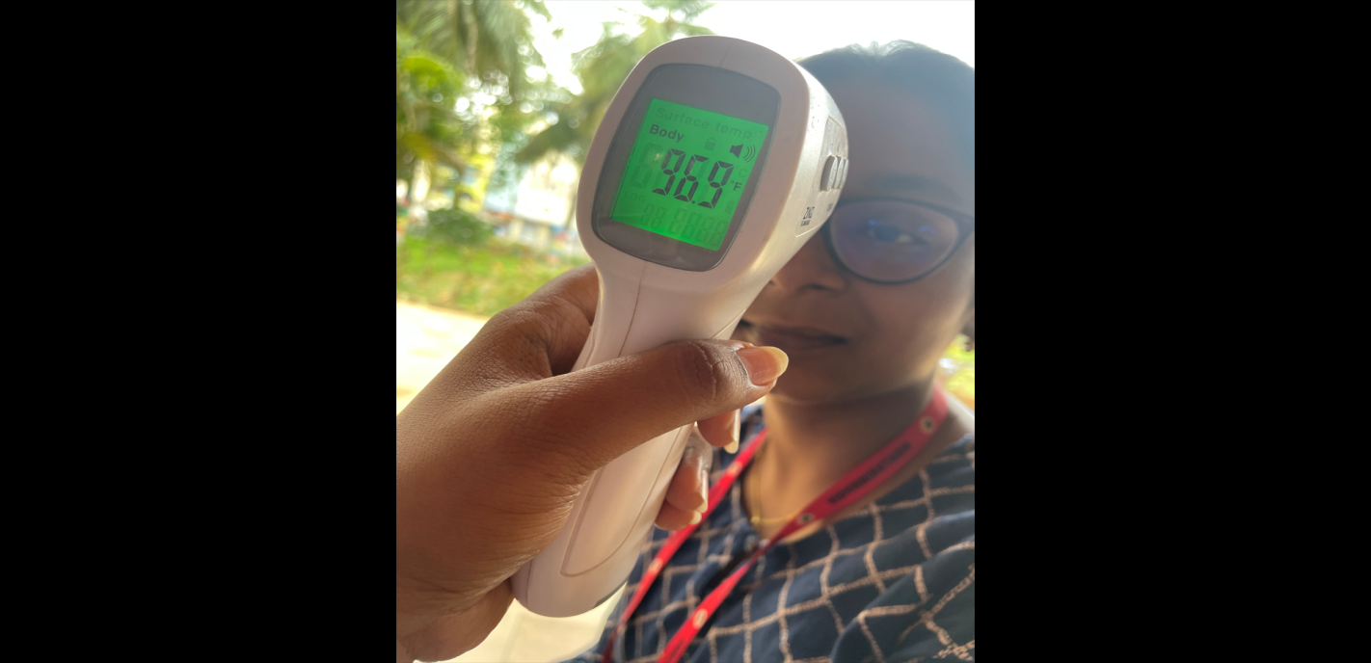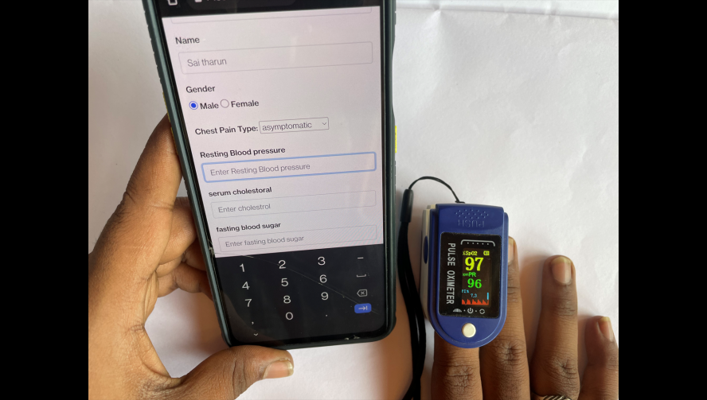

**(b)**

**(a)**

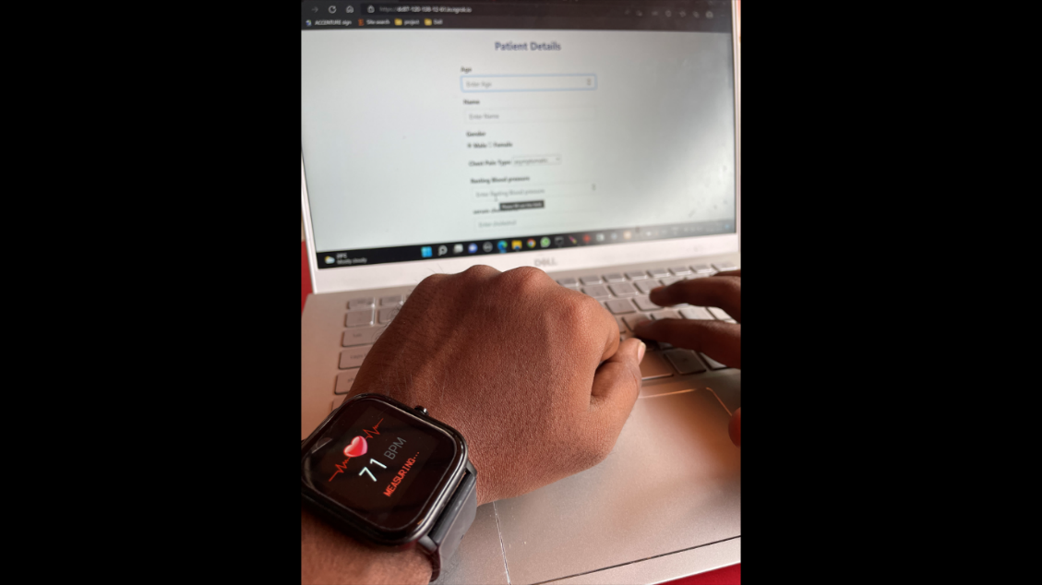

**Fig. 4.1. Devices used for collecting patient health information**

**(e)**

**(d)**

**(c)**

# UML DIAGRAMS

The Unified Modeling Language is abbreviated as UML. It's a graphical notation for describing, visualising, building, and documenting software system artefacts. It is a worldwide industrial standard.

A UML class diagram is used to depict how a programme communicates with its users as well as to describe its object and information structures.

* Problem-Solving
* Improve Productivity
* Easy to Understand

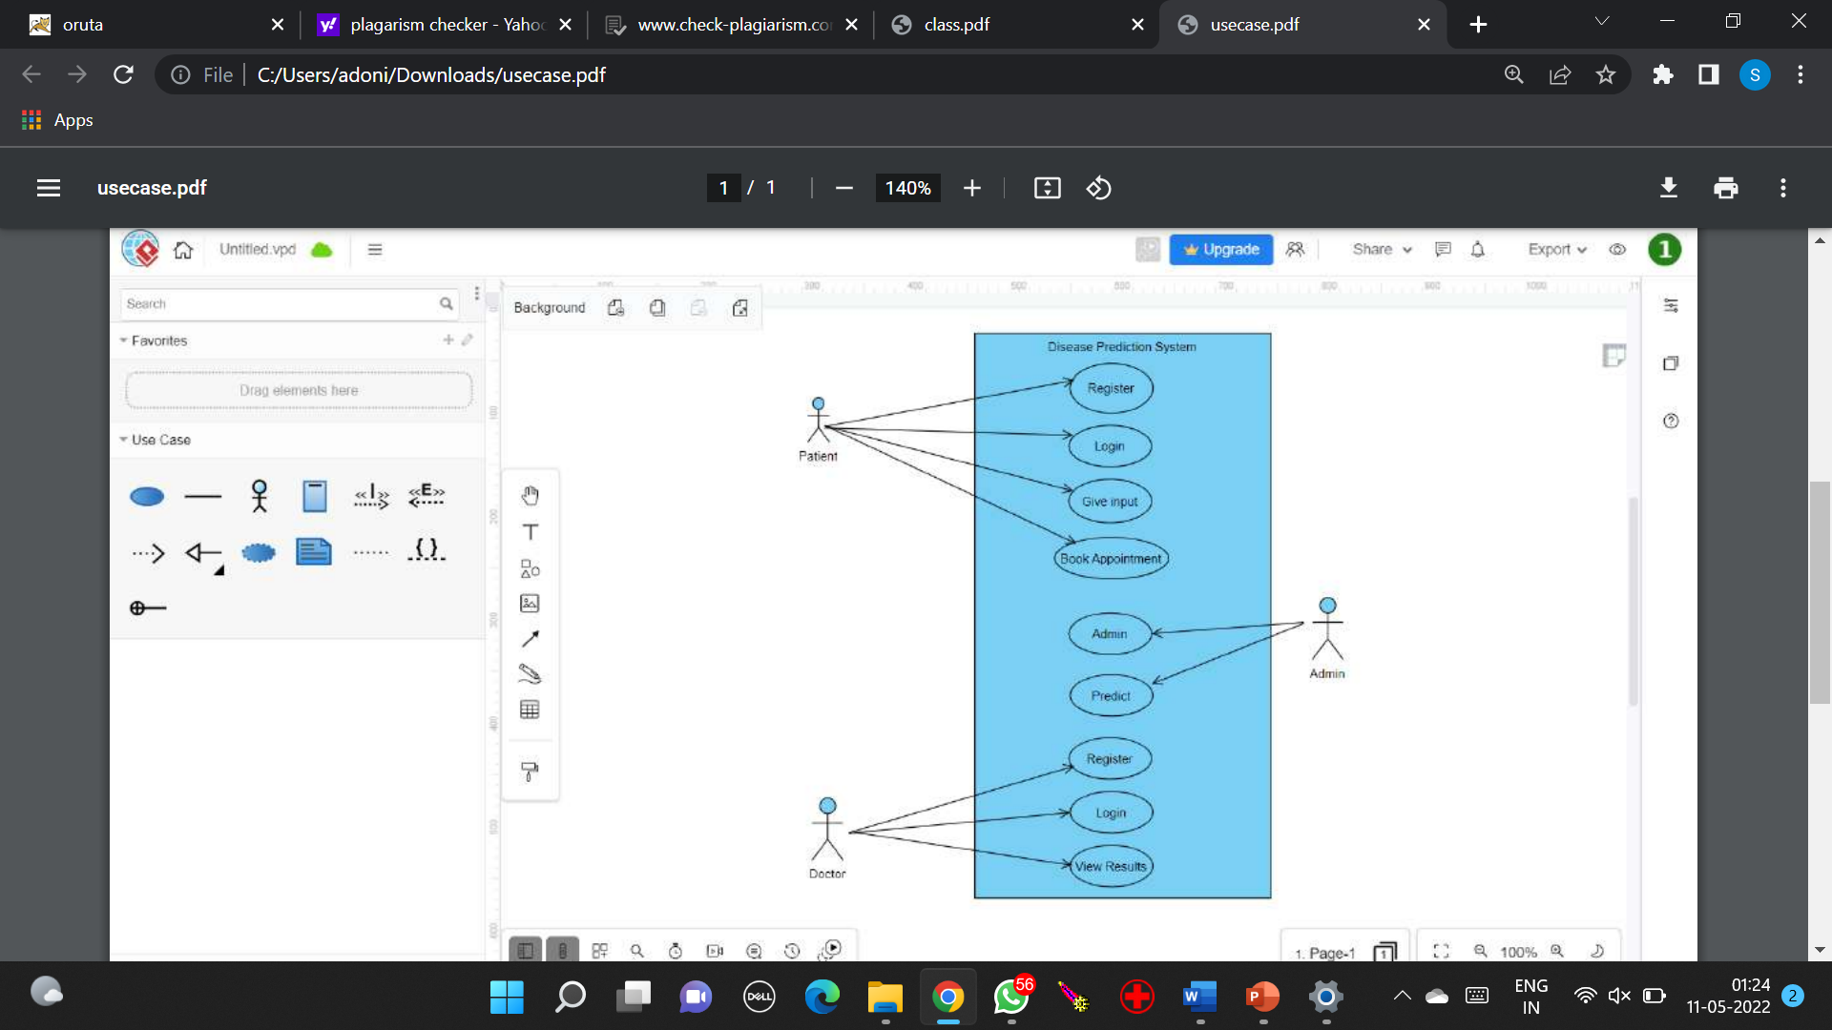**USECASE Diagram**

**Fig. 4.2. Use case diagram for disease prediction**

This diagram shows that there will be three actors in this disease prediction system Patient can register, login, give input (health data) and can book an appointment for doctor consultation.

Admin can view all the information about doctors and patients

Doctor can register, login and can view results.

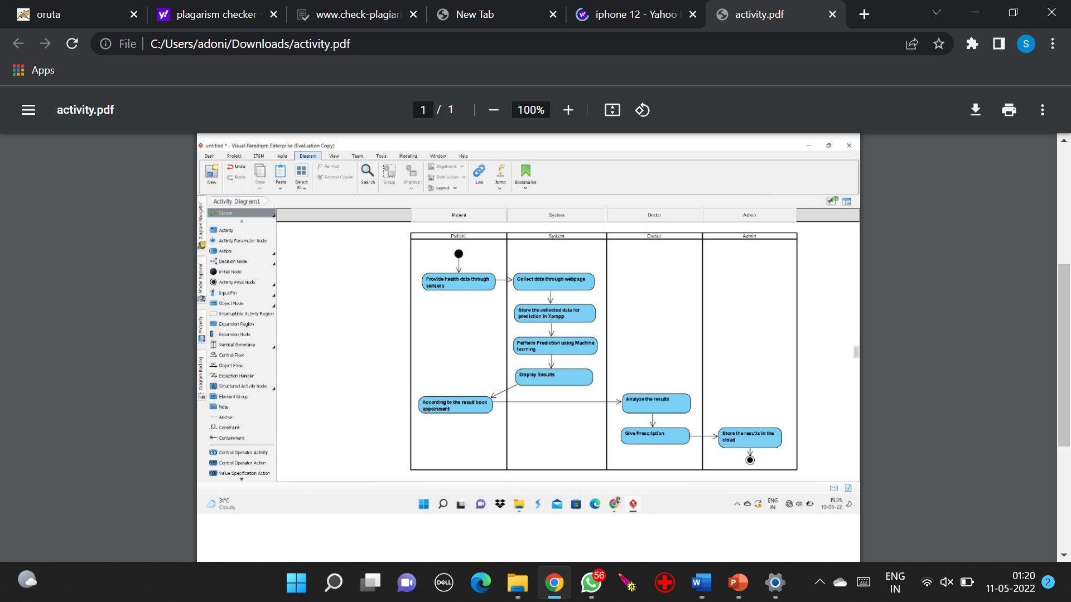**ACTIVITY Diagram**

**tgf**

**Fig. 4.3. Activity diagram for disease prediction**

This diagram shows the set of activities in the disease prediction system. At First, patient can give his/her health data via web page. It stores in the fog node. The prediction will be made in the fog node using the machine learning algorithms. The result will be displayed. Based on the result patient can book an appointment to the doctor. Finally, analysis will be done by the doctor and patient can be treated. All this information will be sent to AWS cloud.

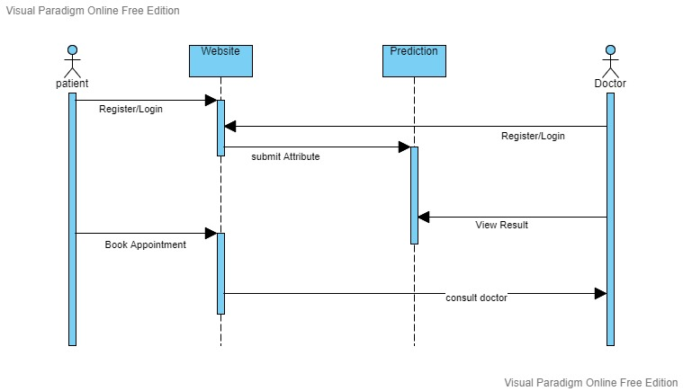**SEQUENCE Diagram**

**Fig. 4.4. Sequence diagram for disease prediction**

This diagram shows the sequence of messages between the objects of the disease prediction system. A Patient can register/login then can submit the data, can view the result, next can book an appointment and can consult the doctor. A doctor can register/Login.

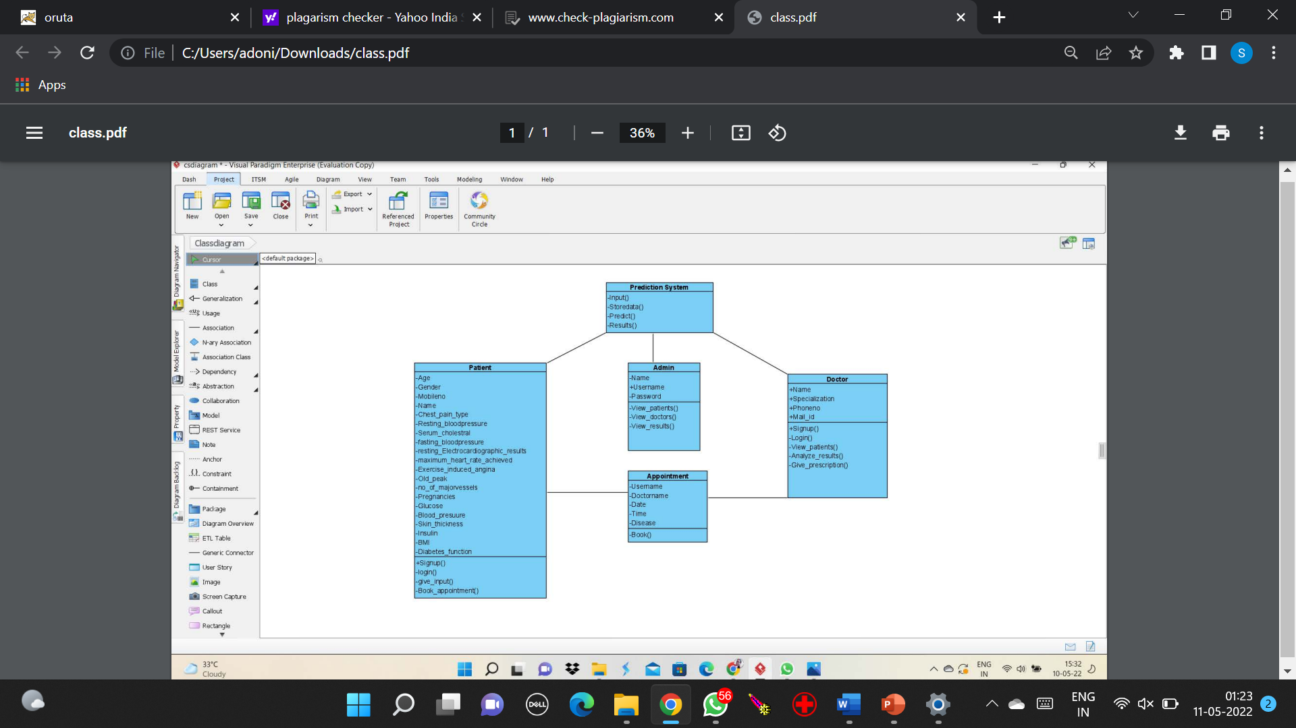**CLASS Diagram**

**Fig. 4.5. Class diagram for disease prediction**

This diagram shows the set of classes in the disease prediction system .

There will be an interaction between patient -> prediction system and appointment.

There will be an interaction between prediction system ->Patient, Admin and Doctor.

There will be an interaction between Appointment-> Patient, Doctor.

There will be an interaction between Doctor-> Prediction System, Appointment**.**

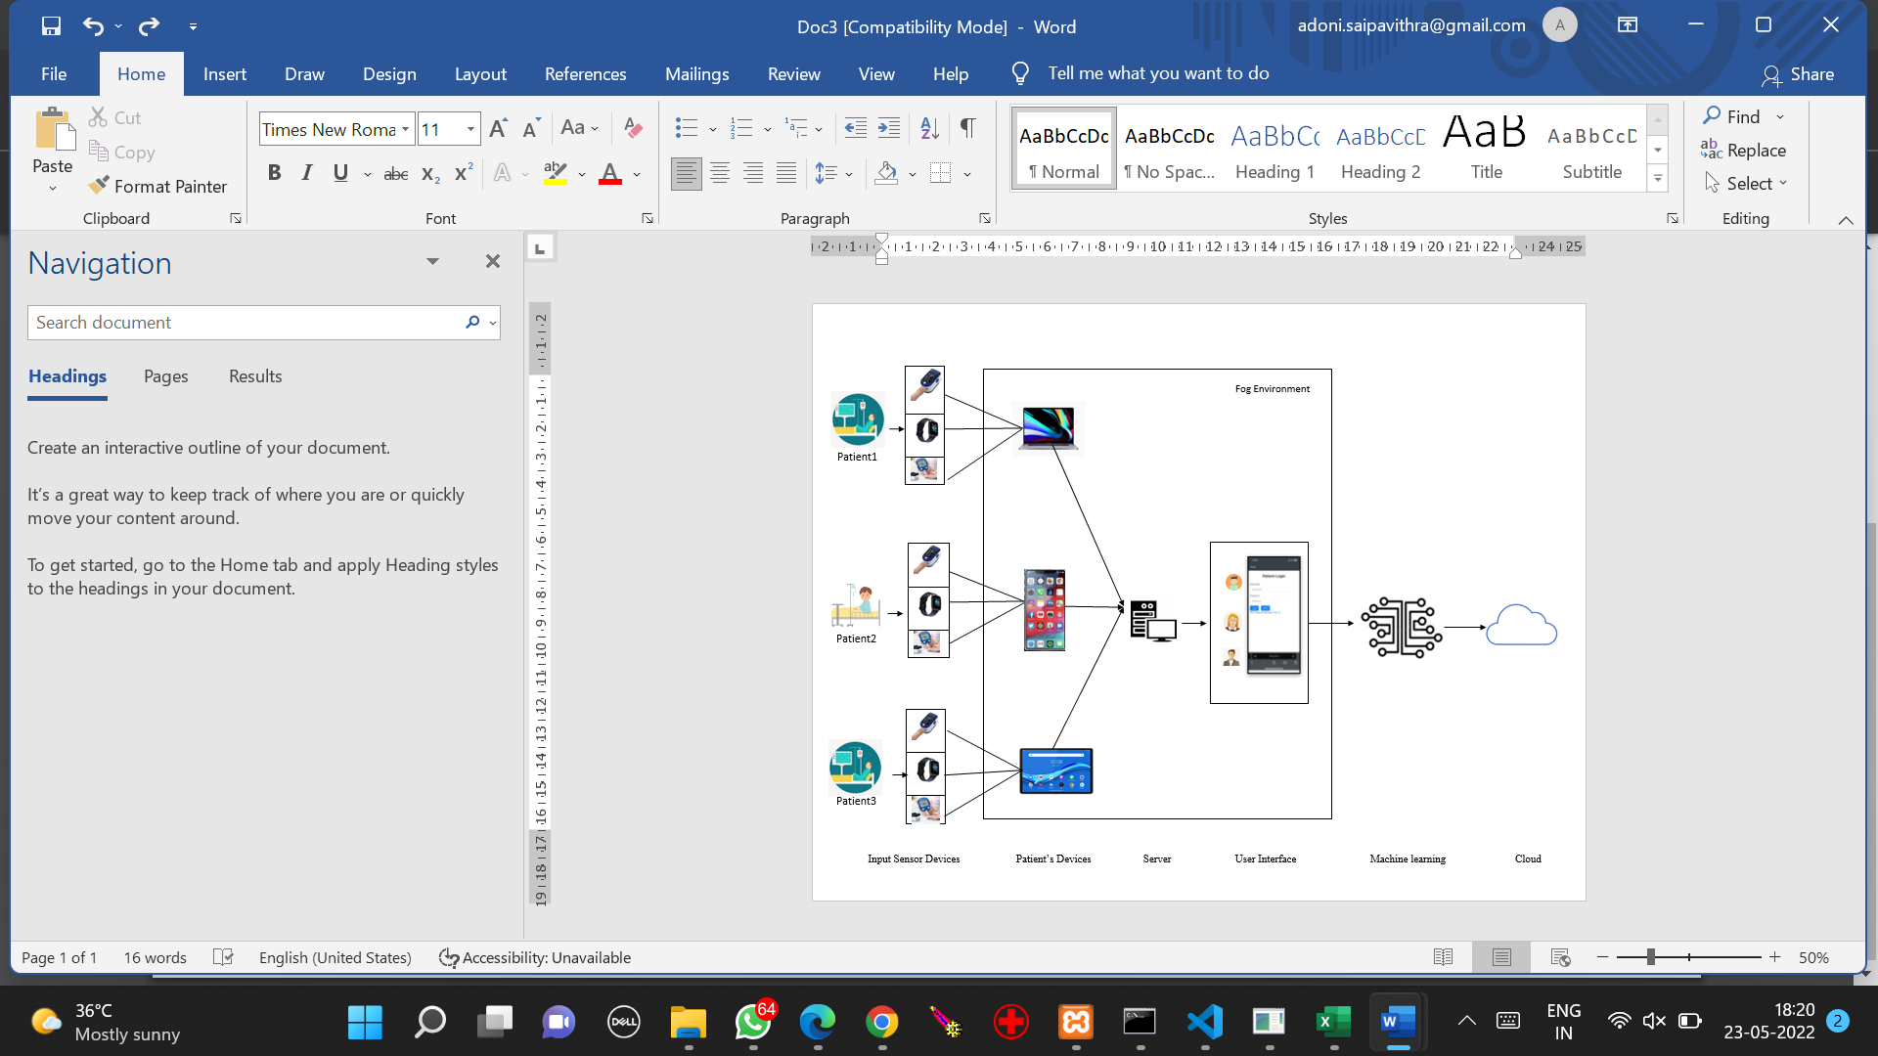

**Fig. 4.6. Implementation of IoT Enabled Prediction of Diabetic-Cardio Disease through Fog Computing**

**59,1,0,140,177,0,1,162,1,0,2,1,3,0**

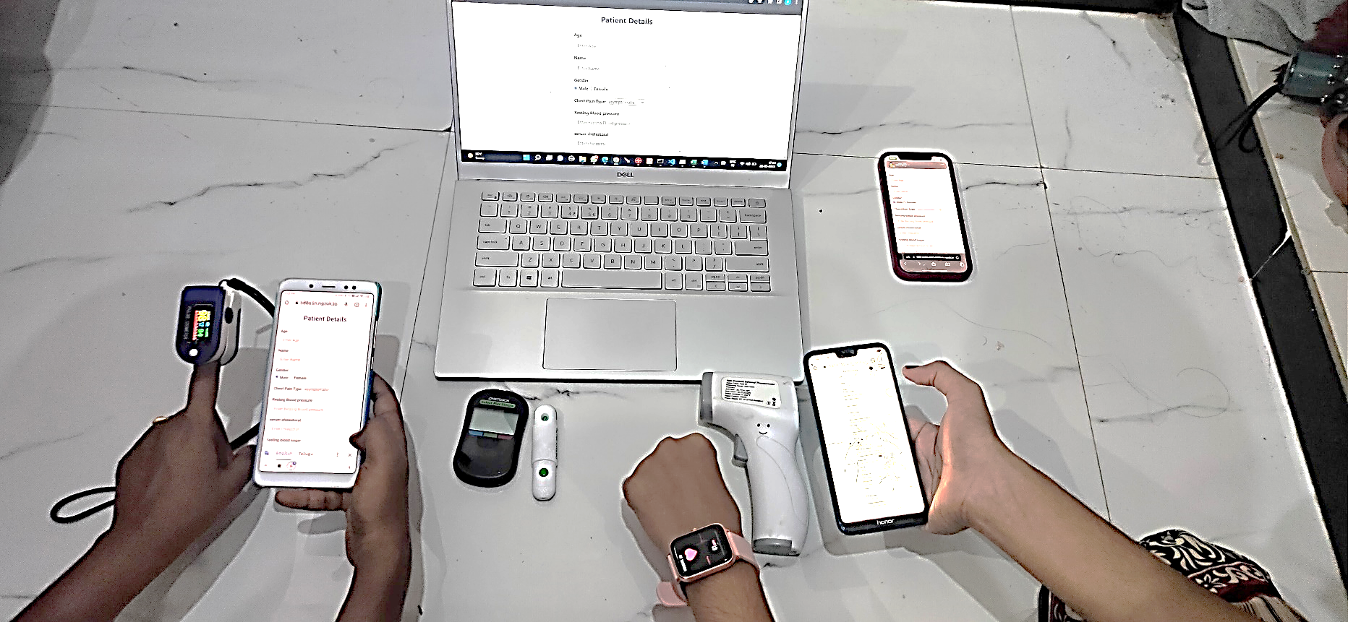

**Server**

**(Fog Node)**

**Patient 2 (Fog Device)**

**Patient 3 (Fog Device)**

**Patient 1 (Fog Device)**

**Fig. 4.7. Showing Fog Environment**

Here, one or two patient devices connected in same network and a server forms Fog Environment. The Server acts as a **Fog Node** and patient devices acts as **Fog Devices**.

One or more devices acting as Fog Devices performs the tasks which are handled by Fog Node. All the requests are handled by Fog Node.

Thus, we built a Fog Environment for our application.

# PROJECT IMPLEMENTATION

To execute the machine learning code written in python, we must install python and install required web framework **Flask** and libraries like numpy, pandas and sklearn.

Then, go to the directory where python runnable file is located and execute the command **python main.py**

This gives a port address [**http://127.0.0.1:5000**](http://127.0.0.1:5000)

In order provide static values to the python file, we have created a web page for taking inputs.

For accessing the in other devices, we made the local host url to public with the help of **xampp Apache**. Here, for backend storage we used **xampp MySql.**For accessing the in other devices, we made the local host url to public with the help of **xampp Apache**. Here, for backend storage we used **xampp MySql.**

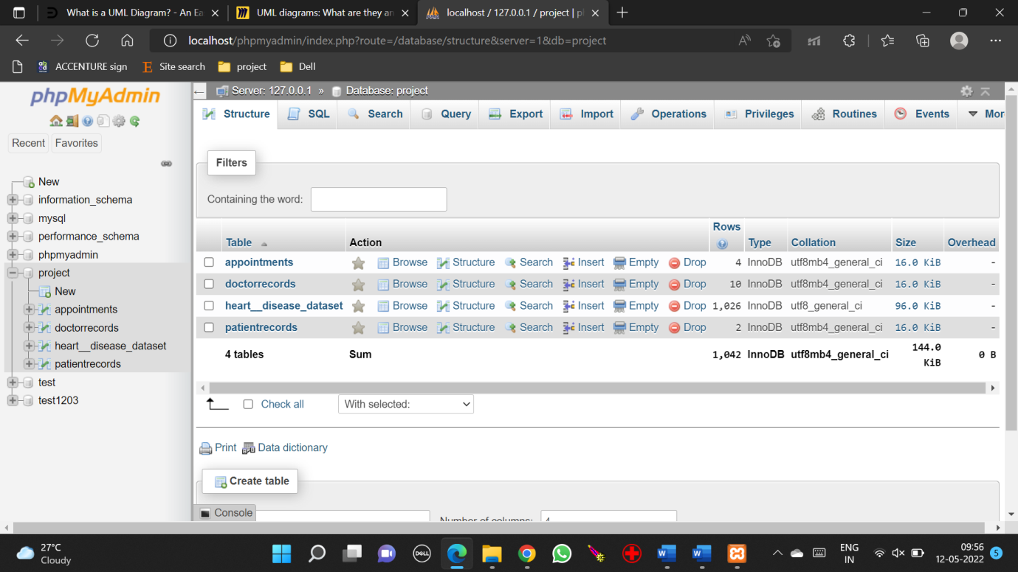Here, we can create database and create required tables.

**Fig. 4.8. Showing PhpMyAdmin**

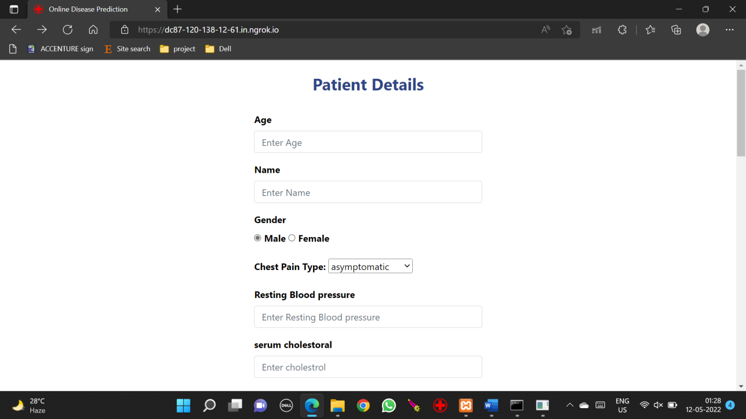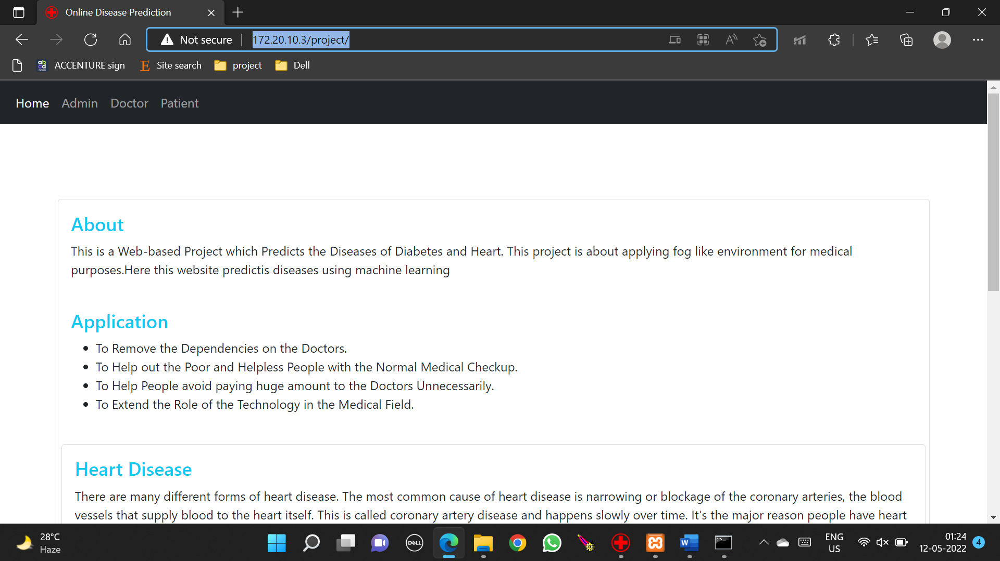**Fig. 4.9. Home.html**

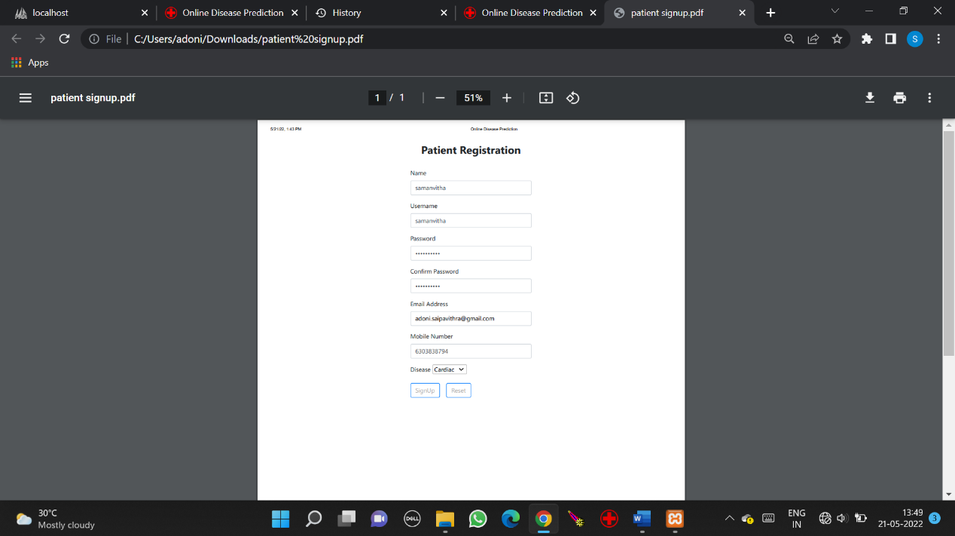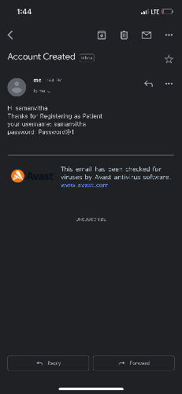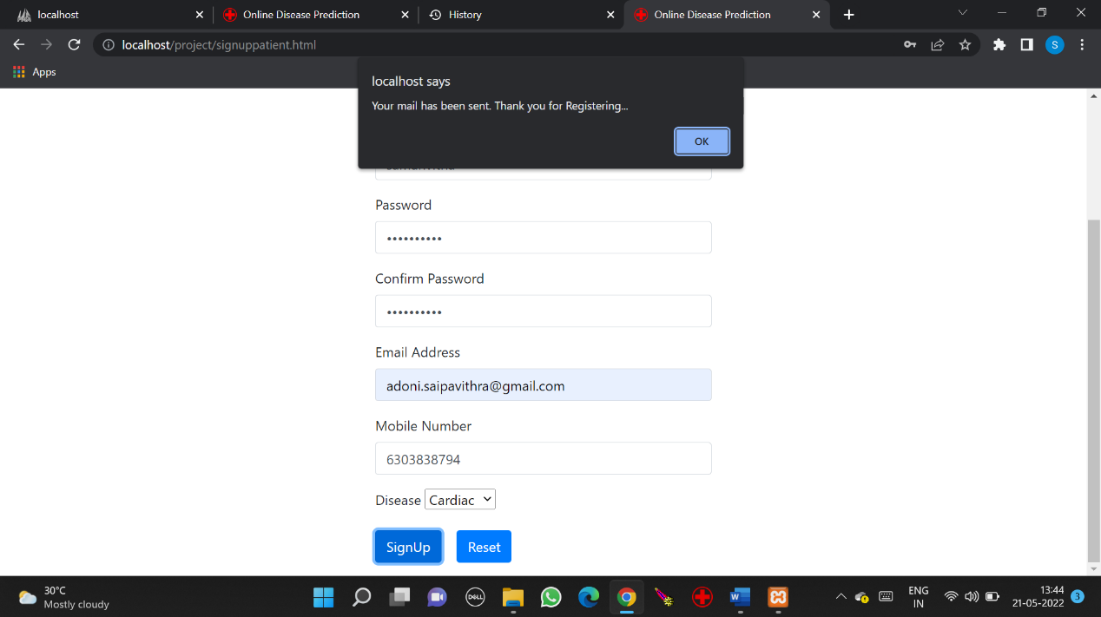 **Fig. 4.10. Patient detail**

**Fig. 4.11. Login Process**

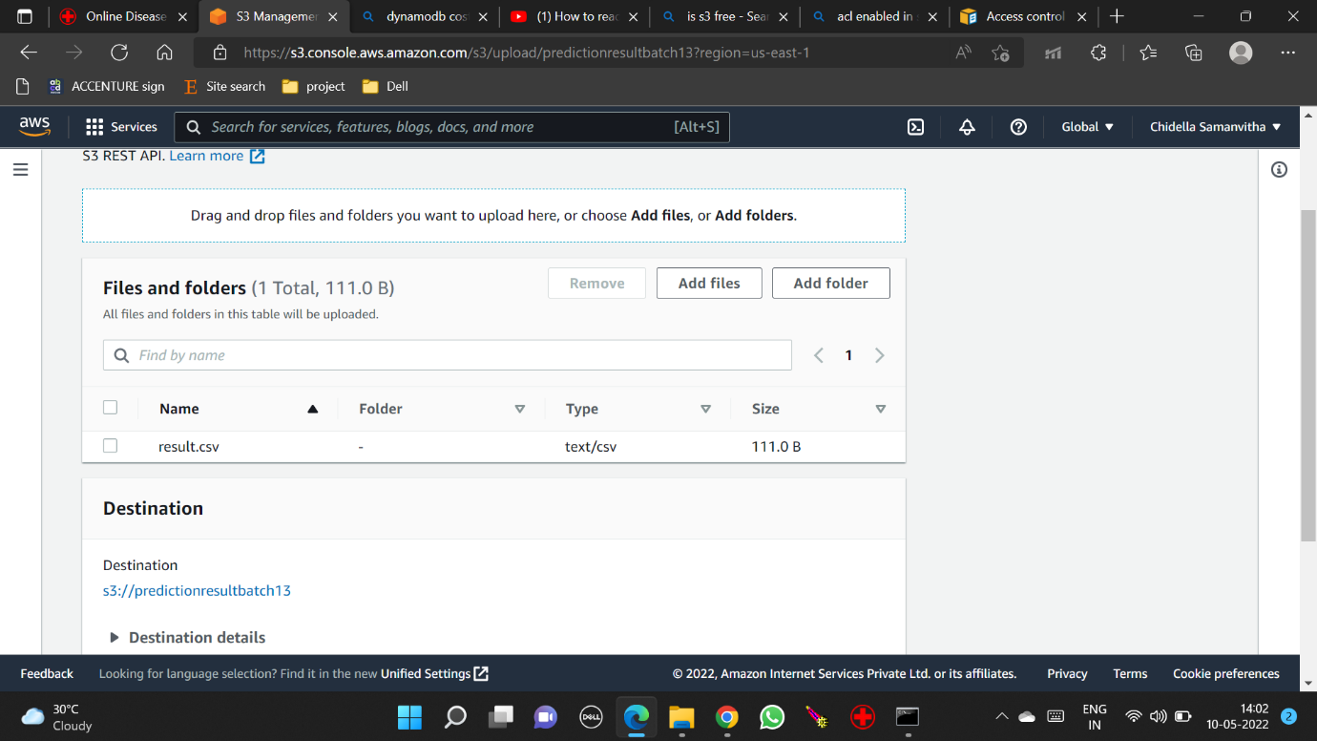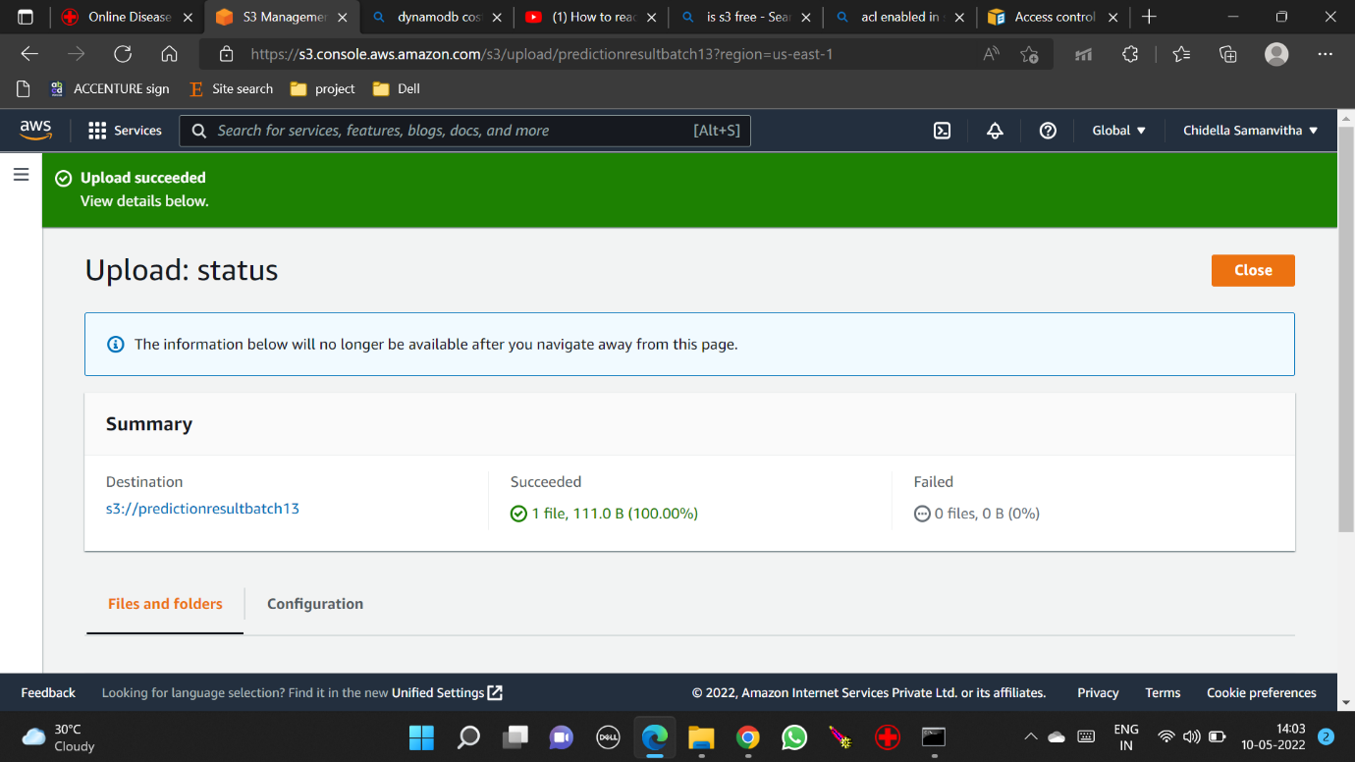After obtaining **result.csv** is uploaded to AWS S3 buckets

**Fig. 4.12. Showing file upload in S3 bucket**

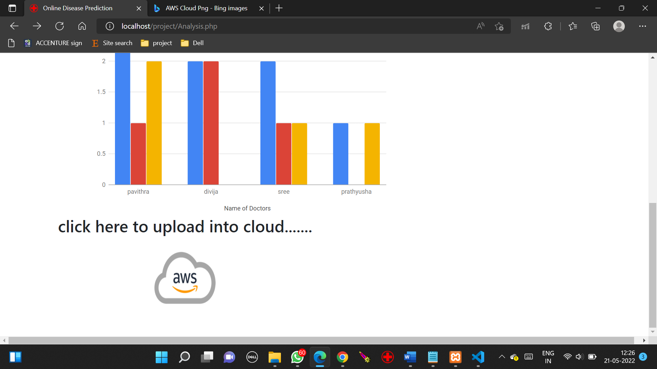

**Fig. 4.13. Showing Upload button to upload result**

# TESTING

The purpose of testing is to discover errors. Testing is the process of trying to discover every conceivable fault or weakness in a work product. It provides a way to check the functionality of components, sub-assemblies and/or a finished product. It is the process of exercising software with the intent of ensuring that the software systemmeetstheirrequirementsandtheuserexpectationsanddoesnotfailinanunacceptable manner. There are various types of tests. Each test type addresses aspecific testing requirement.

To Evaluate the performance of proposed work, we test the system with various input values and observe the outputs.

**Table 5.1. Table showing the Testcases, Expected and Actual Outputs**

|  |  |  |  |  |
| --- | --- | --- | --- | --- |
| **Sl.No.** | **Input Values** | **Expected Output** | **Actual Output** | **Result** |
| **1.** | **Heart:** 34,0,1,118,210,0,1,192,0,1,2,0,2 | YES | YES | **TRUE** |
| **Diabetes:** 4,123,80,15,176,32,0.443,34 | NO | NO |
| **2.** | **Heart:**  1,0,0,1,1,1,0,1,1,1,0,1,0  **Diabetes:**  1,1,1,1,1,1,1,1 | NO | NO | **TRUE** |
| NO | NO |
| **3.** | **Heart:**  77,1,0,125,304,0,0,162,1,0,2,3,2 | NO | NO | **TRUE** |
| **Diabetes:**  0,129,110,46,130,67.1,0.319,77 | YES | YES |
| **4.** | **Heart:**  56,1,0,120,236,0,1,178,0,0.8,2,0,2 | YES | YES | **TRUE** |
| **Diabetes:**  0,84,82,31,125,38.2,0.233,23 | YES | YES |

|  |  |  |  |  |
| --- | --- | --- | --- | --- |
| **Sl.No.** | **Input Values** | **Expected Output** | **Actual Output** | **Result** |
| **5.** | **Heart:**  21,0,0,99,94,0,0,120,0,6.2,0,1,1 | **NO** | **NO** |  |
| **Diabetes:**  0,139,62,17,210,22.1,0.207,21,0 | **NO** | **NO** | **TRUE** |
| **6.** | **Heart:**  21,0,1,136,319,1,0,152,0,0,2,2,2 | **NO** | **YES** | **FALSE** |
| **Diabetes:**  0,139,62,17,210,22.1,0.207,21 | **NO** | **NO** |
| **7.** | **Heart:**  22,1,0,112,98,1,0,90,0,1,1,2,1 | **NO** | **NO** |  |
| **Diabetes:**  0,120,78,0,0,25,0.409,22,0 | **NO** | **NO** | **TRUE** |
| **8.** | **Heart:**  42,1,0,145,99,0,0,132,0,2,1,2,1 | **NO** | **NO** |  |
| **Diabetes:**  2,100,66,20,90,32.9,0.867,42 | **YES** | **YES** | **TRUE** |
| **9.** | **Heart:**  47,1,0,112,204,0,1,143,0,0.1,2,0,2 | **YES** | **YES** |  |
| **Diabetes:**  0,100,70,26,50,30.8,0.597,47 | **NO** | **NO** | **TRUE** |
| **10.** | **Heart:**  35,1,0,140,177,0,1,162,1,0,2,1,3 | **NO** | **NO** |  |
| **Diabetes:**  2,158,90,0,0,31.6,0.805,35 | **YES** | **YES** | **TRUE** |

These results are stored in an excel sheet **result.csv**

# 6. RESULTS

In today’s healthcare sector, research is dominated by machine learning and statistics. Computer algorithms can process constantly increasing volumes of data to carve insightful ideas on improving patient care, diagnosis, drug discovery. Technology helps caregivers let go of routine tasks and focus on helping people.

Hence, we should find which algorithm is best to use for certain application among the available algorithms.

Here in our project, we have taken knn, naïve bayes, logistic regression algorithms for calculating the predicted result. We have to find the highest accurate algorithm among them. Hence, we perform training and testing on same database for different algorithms and find their accuracies.

For first dataset,

knn gave 75.96 train accuracy and 68.75 test accuracy, lr gave 84.67 train accuracy and 75.00 test accuracy, gaussian naïve bayes gave 83.62 train accuracy and 75.00 test accuracy.

For second dataset,

knn gave 91.68 train accuracy and 80.00 test accuracy, lr gave 78.05 train accuracy and 84.00 test accuracy, gaussian naïve bayes gave 75.79 train accuracy and 78.00 test accuracy.

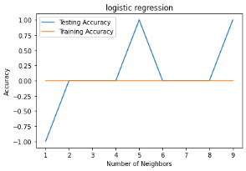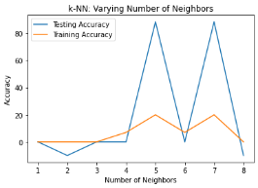

**Fig. 6.1. KNN Accuracy Graph Fig. 6.2. LR Accuracy Graph**

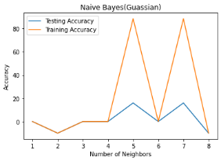

**Fig. 6.3. Naïve Bayes Accuracy Graph**

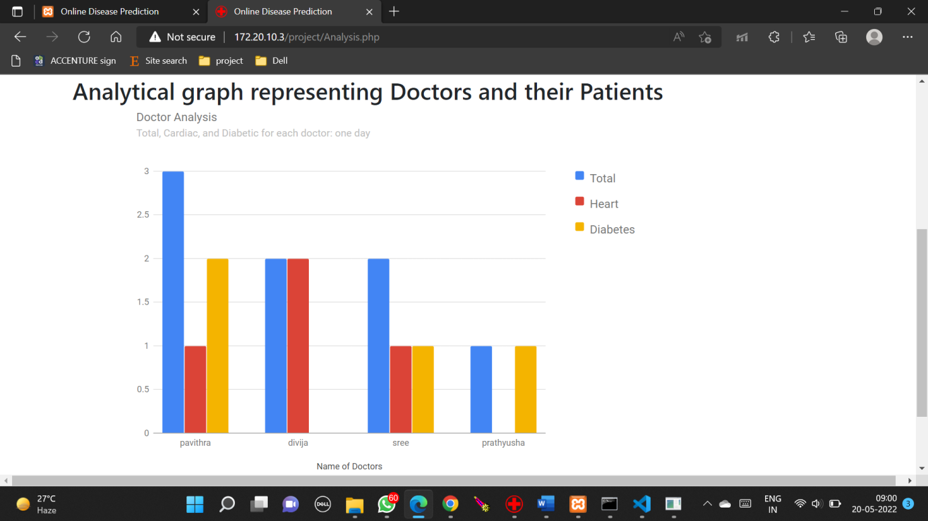

**Fig. 6.4. Graph representing number of patients visited each doctor**

**Fig. 6.5.** **Graph Showing Real Time Values Of Male Patients**

**Fig. 6.6.** **Graph Showing Real Time Values Of Female Patient**s

# 7. CONCLUSION

In the current healthcare system, the use of Machine Learning plays a crucial role. It can result in automated processes for collecting and verifying data, correcting and aggregating information from different, and providing protected data, with condensed cybercrime chances and which also supports disseminated information, with system redundancy

IoT Enabled Prediction of Diabetic-Cardio Disease through Fog Computing system overcomes the above drawbacks.

* Makes computations faster and easier.
* This is cost efficient.
* Books appointment for doctor.
* Reduce latency and bandwidth on the cloud.

Future work

* The security and privacy for accessing patient medical data and some hybrid clustering and classification model can be added to enhance the performance of the prediction results.
* Reducing the threats caused by Attackers.

# REFERENCES

1. P. G. SHYNU 1, VARUN G. MENON, R. LAKSHMANA KUMAR, SEIFEDINE KADRY, YUNYOUNG NAM, “Blockchain-Based Secure Healthcare Application for Diabetic-Cardio Disease Prediction in Fog Computing”, 45706 - 45720,10 March 2021.
2. André Henrique Mayer;ViniciusFaccoRodrigues;Cristiano André da Costa;Rodrigo da Rosa Righi;AlexRoehrs;Rodolfo Stoffel Antunes, “FogChain: A Fog Computing Architecture Integrating Blockchain and Internet of Things for Personal Health Records”, 122723 – 122737, 01 September 2021
3. Pratik Kanani, MamtaPadole, “Implementing and Evaluating Health as a Service in Fog and Cloud Computing using Raspberry Pi”, July 21, 2020.
4. Anand Paul, Hameed Pinjari,Won-Hwa Hong, Hyun Cheol Seo,andSeungmin Rho, “Fog Computing-Based IoT for Health Monitoring System”, 22 Oct 2018
5. Omar Cheikhrouhou; Redowan Mahmud; Ramzi Zouari; Muhammad Ibrahim, “One-Dimensional CNN Approach for ECG Arrhythmia Analysis in Fog-Cloud Environments”,16July,2021
6. S. Tuli, N. Basumatary, S. S. Gill, M. Kahani, R. C. Arya, G. S. Wander, and R. Buyya, ‘‘HealthFog: An ensemble deep learning based smart healthcare system for automatic diagnosis of heart diseases in integrated IoT and fog computing environments,’’ Future Gener. Comput. Syst., vol. 104, pp. 187–200, Mar. 2020
7. “Smart Heart Disease Prediction System with IoT and Fog Computing Sectors Enabled by Cascaded Deep Learning Model”, K. Butchi Raju, Suresh Dara, Ankit Vidyarthi, V. MNSSVKR Gupta, and Baseem Khan, 10 Jan 2022
8. “IoT and Fog Computing Based Prediction and Monitoring System for Stroke Disease”, Ajay Dev a, Sanjay Kumar Malik Vol.12 No.12 (2021), 3211-3223
9. “Fog computing in health: A systematic literature review”,Humberto Jorge de Moura Costa, Cristiano André da Costa, Rodrigo da Rosa Righi& Rodolfo Stoffel Antunes volume 10, pages1025–1044 (2020)

[10] “FogMed: A Fog-Based Framework for Disease Prognosis Based Medical SensorData Streams”, Le Sun, Qiandi Yu, Dandan Peng, Sudha Subramani2and Xuyang Wang, 22 July 2020

[11] HTML 5 Black Book: Covers Css3, Javascript,XML, XHTML, Ajax,

PHP And Jquery, by [Kogent Learning Solutions Inc](https://www.goodreads.com/author/show/6439029.Kogent_Learning_Solutions_Inc)

[12] “Ajax Introduction” [**W3Schools Online Web Tutorials**](https://www.w3schools.com/)**,** drafted on may 18 2022 at 10:30 A.M.

[13] “Pass A Value From Php To Html” [**Newest Questions - Stack Overflow**](https://stackoverflow.com/questions)**,** drafted on may 13 2022

[14] The Joy of PHP: A Beginner's Guide to Programming Interactive Web Applications with PHP and mySQL Kindle Edition

by [Alan Forbes](https://www.amazon.in/Alan-Forbes/e/B00BBPOUOA/ref=dp_byline_cont_ebooks_1)